https://www.zabbix.com/documentation/2.0/manual/concepts/proxy

4 Proxy

Overview
Zabbix proxy is a process that may collect monitoring data from one or more monitored devices and send the information to the Zabbix server, essentially working on behalf of the server. All collected data is buffered locally and then transferred to the Zabbix server the proxy belongs to.
Deploying a proxy is optional, but may be very beneficial to distribute the load of a single Zabbix server. If only proxies collect data, processing on the server becomes less CPU and disk I/O hungry.
A Zabbix proxy is the ideal solution for centralized monitoring of remote locations, branches and networks with no local administrators.
Zabbix proxy requires a separate database.
The databases that are supported with Zabbix proxy are SQLite, MySQL and PostgreSQL. Using Oracle or IBM DB2 is at your own risk and may contain limitations as is the case with low-level discovery rules.
See also: Using proxies in a distributed environment

Proxy process
Zabbix proxy runs as a daemon process. The proxy can be started by executing:
shell> cd sbin
shell> ./zabbix_proxy
You can use the following command line parameters with Zabbix proxy:
-c --config <file> absolute path to the configuration file
-R --runtime-control <option> perform administrative functions
-h --help give this help
-V --version display version number
Examples of command line parameters:
shell> zabbix_proxy -c /usr/local/etc/zabbix_proxy.conf
shell> zabbix_proxy --help
shell> zabbix_proxy -V

Runtime control
Runtime control options:
Option | Description
config_cache_reload | Reload configuration cache. Ignored if cache is being currently loaded.  Active Zabbix proxy will connect to the Zabbix server and request configuration data.
Example of using runtime control to reload the proxy configuration cache:
shell> zabbix_proxy -c /usr/local/etc/zabbix_proxy.conf -R config_cache_reload
Runtime control is not supported on OpenBSD and NetBSD.

Process user
Zabbix proxy is designed to run as a non-root user. It will run as whatever non-root user it is started as. So you can run proxy as any non-root user without any issues.
If you will try to run it as 'root', it will switch to a hardcoded 'zabbix' user, which must be present on your system.
These settings currently cannot be user configured, neither during compilation nor in the configuration file.

Configuration file
See the configuration file options for details on configuring zabbix_proxy.

https://www.zabbix.com/documentation/2.0/manual/distributed_monitoring/proxies

1 Proxies

Overview
A Zabbix proxy can collect performance and availability data on behalf of the Zabbix server. This way, a proxy can take on itself some of the load of collecting data and offload the Zabbix server.
Also, using a proxy is the easiest way of implementing centralized and distributed monitoring, when all agents and proxies report to one Zabbix server and all data is collected centrally.
A Zabbix proxy can be used to:
- Monitor remote locations
- Monitor locations having unreliable communications
- Offload the Zabbix server when monitoring thousands of devices
- Simplify the maintenance of distributed monitoring
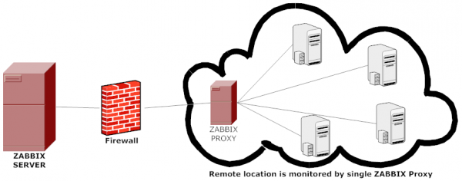
The proxy requires only one TCP connection to the Zabbix server. This way it is easier to get around a firewall as you only need to configure one firewall rule.
Zabbix proxy must use a separate database. Pointing it to the Zabbix server database will break the configuration.
All data collected by the proxy is stored locally before transmitting it over to the server. This way no data is lost due to any temporary communication problems with the server. The ProxyLocalBuffer and ProxyOfflineBuffer parameters in the proxy configuration file control for how long the data are kept locally.
Zabbix proxy is a data collector. It does not calculate triggers, process events or send alerts. For an overview of what proxy functionality is, review the following table:
Function |  | Supported by proxy
Items
 | Zabbix agent checks | Yes
 | Zabbix agent checks (active) | Yes ¹
 | Simple checks | Yes
 | Trapper items | Yes
 | SNMP checks | Yes
 | SNMP traps | Yes
 | IPMI checks | Yes
 | JMX checks | Yes
 | Log file monitoring | Yes
 | Internal checks | No
 | SSH checks | Yes
 | Telnet checks | Yes
 | External checks | Yes
Built-in web monitoring |  | Yes
Network discovery |  | Yes
Low-level discovery |  | Yes
Calculating triggers |  | No
Processing events |  | No
Sending alerts |  | No
Remote commands |  | No
[1] To make sure that an agent asks the proxy (and not the server) for active checks, the proxy must be listed in the ServerActive parameter in the agent configuration file.

Configuration
Once you have installed and configured a proxy, it is time to configure it in the Zabbix frontend.

Adding proxies
To configure a proxy in Zabbix front end:
- Go to: Administration → DM
- Click on Create proxy (or on the name of an existing proxy)
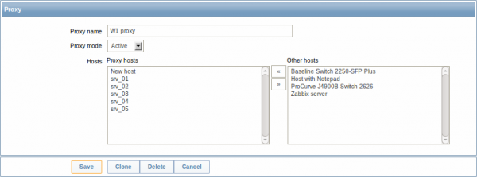
Parameter | Description
Proxy name | Enter the proxy name. It must be the same name as in the Hostname parameter in the proxy configuration file.
Proxy mode | Select the proxy mode.  Active - the proxy will connect to the Zabbix server and request configuration data  Passive - Zabbix server connects to the proxy
Hosts | Add hosts to be monitored by the proxy.

Host configuration
You can specify that an individual host should be monitored by a proxy in the host configuration form, using the Monitored by proxy field.
